## **Monte Carlo Simulation to Identify Independence and $t$-distribution**

**Introduction**

The student’s theorem have stated that following the definition of a t-distributed RV, the independence of $\bar{X}$ and $S^{2}$ with r degrees of freedom iff will lead to $T=\sqrt{n}\frac{\bar{X}-μ}{S}∼t_{n-1}$. Thus, it aroused our interest to investigate possible dependents of $Z∼ N(0,1)$ and $U∼ {χ_{r}}^{2}$ such that $T=\frac{z}{\sqrt{U/r}}∼t_{r}$. Different techniques such as Monte Carlo simulations and transformations methods are being applied while solving the questions. Results were being obtained throughout the exploration, which $Z$ and $U$ are not independent as $X_{1}$ and $S^{2}$ are not independent.

**Student’s Theorem**

According to Student’s Theorem, if $X_{1}, ... ,X_{n}∼N(μ,\frac{σ^{2}}{n})$, the sample mean $\bar{X}=\frac{1}{n}\sum_{i=1}^{n}{}X_{i}∼N(μ,\frac{σ^{2}}{n})$ and sample variance $S^{2}=\frac{1}{n-1}\sum_{i=1}^{n}{}{(X}_{i}-\bar{X} )^{2}$ are independent. The independence of $\bar{X}$ and $S^{2}$ leads to $T=\sqrt{n}\frac{\bar{X}-μ}{S}∼t_{n-1}$. This follows the definition of a $t$-distributed RV.

**The definition of a $t$-distributed RV**

Let $Z∼N(0,1)$ and $U∼{χ_{r}}^{2}$ such that $Z$ and $U$ are independent. A RV $T$ is said to have a $t$-distribution with $r$ degrees of freedom iif $T=\frac{Z}{\sqrt{U/r}}∼t_{r}$.

**Independence and $t$-distribution**

Suppose $X_{1}, ... ,X_{n}∼N(0,1)$. Let $Z=X_{1}$ and $U=(n-1)S^{2}$, so that $Z∼N(0,1)$ and $U∼{χ_{n-1}}^{2}$. It follows that $Z$ and $U$ are not independent if $X_{1}$ and $S^{2}$ are not independent according to the theorem and definition explained above.

Suppose we consider the case $n=2$, $X_{1},X_{2}∼N(0,1)$, so that $Z=X_{1}$ and $U=S^{2}=\frac{1}{2}(X_{1}-X_{2})^{2}$.

We first obtain the joint distribution of $X$. Since $X_{1}$ and $X_{2}$ are standard normal distributions, we have the following equation.

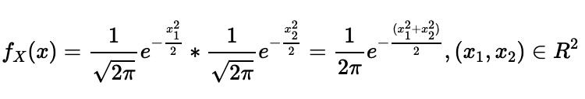

In addition, suppose $Y=(Z,U)^{T}, X=(X_{1},X_{2})^{T}$.

We use the transformation method by equating and arranging the vectors $Y$ and $X$ with respect to $x_{1}$ and $x_{2}$ as follows;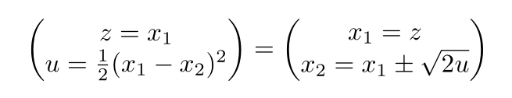

⇔

Thus, we have $x_{1}=z$ and $x_{2}=x_{1}±\sqrt{2u}$.

Since we have two different values for $x_{2}$, there are two ways to define range as following;

$$R_{1}=\{(x_{1},x_{2})| x_{1}<x_{2}, x_{1},x_{2}∊ R\}$$

$$R_{2}=\{(x_{1},x_{2})| x_{1} ≥ { x}_{2}, x_{1},x_{2}∊ R\}$$

For $R_{1}=\{(x_{1},x_{2})| x_{1}<x_{2}, x_{1},x_{2}∊ R\}$, we have $x_{1}=z$ and $x_{2}=x_{1}+\sqrt{2u}$ where $z ∊ R , u>0$, hence, we obtain the following for $| J |$.

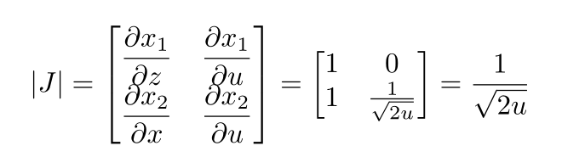

and the following joint distribution.

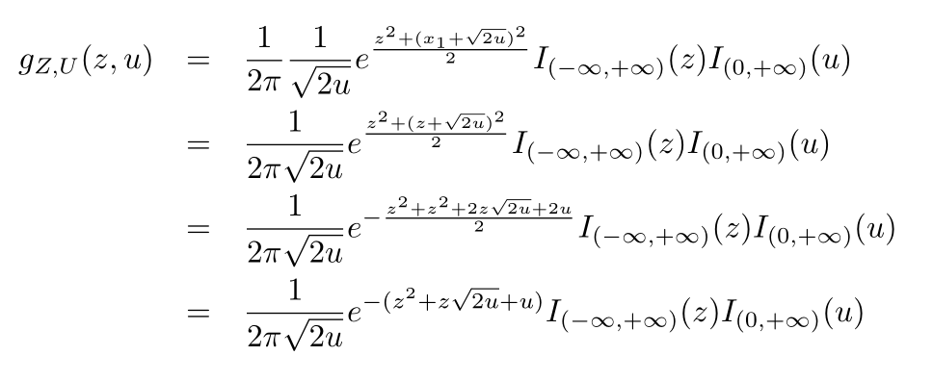

Similarly, for $R_{2}=\{(x_{1},x_{2})| x_{1} ≥ { x}_{2}, x_{1},x_{2}∊ R\}$, we obtain $| J |$ and joint distribution as follows.

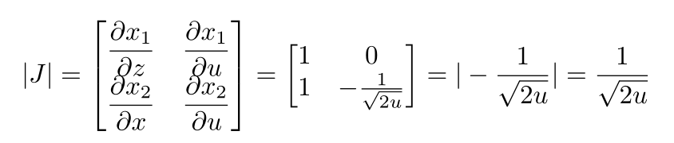

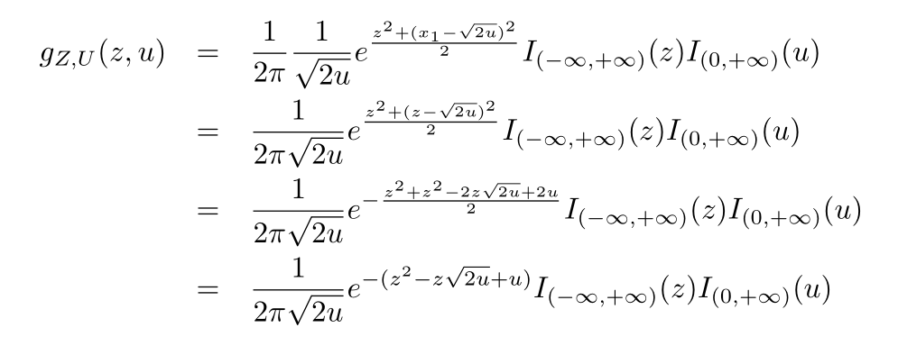

Therefore, we obtain the the joint distribution of $x_{1}$ and $x_{2}$ as follows;

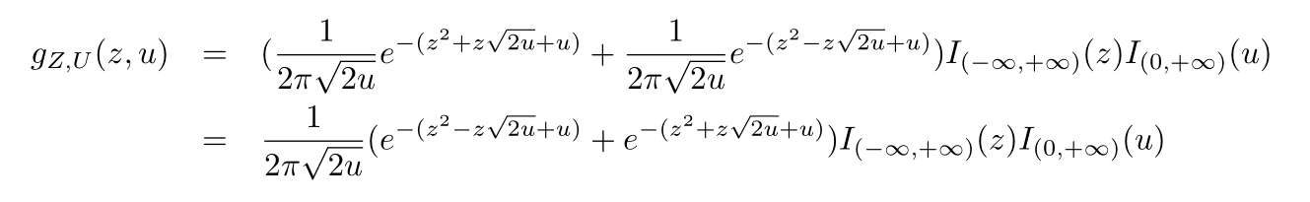

Suppose we have independent $Z$ and $U$ such as

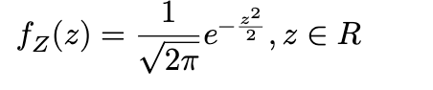



Then, the joint distribution would be



which does not equal to $g_{Z,U}(z,u)$.

Therefore, $Z$ and $U$ are not independent as $X_{1}$ and $S^{2}$ are not independent.

**Monte Carlo Simulations**

Now we are conducting Monte Carlo simulation to compute the $t$-RV $T=\frac{z}{\sqrt{U/n-1}}$, where $Z=X_{1}$ and $U=(n-1)S^{2}$. 10,000 random samples were generated from $X_{1}$, … , $X_{n}∼N(0,1)$ for fixed $n$ = 5,10,15, and 25, each of the random samples is computing the distribution of $T=\frac{z}{\sqrt{U/n-1}}$. The following histograms are demonstrating the distribution of $T=\frac{z}{\sqrt{U/n-1}}$ and the density curves of the $t_{n-1}$ distribution of each $n$.

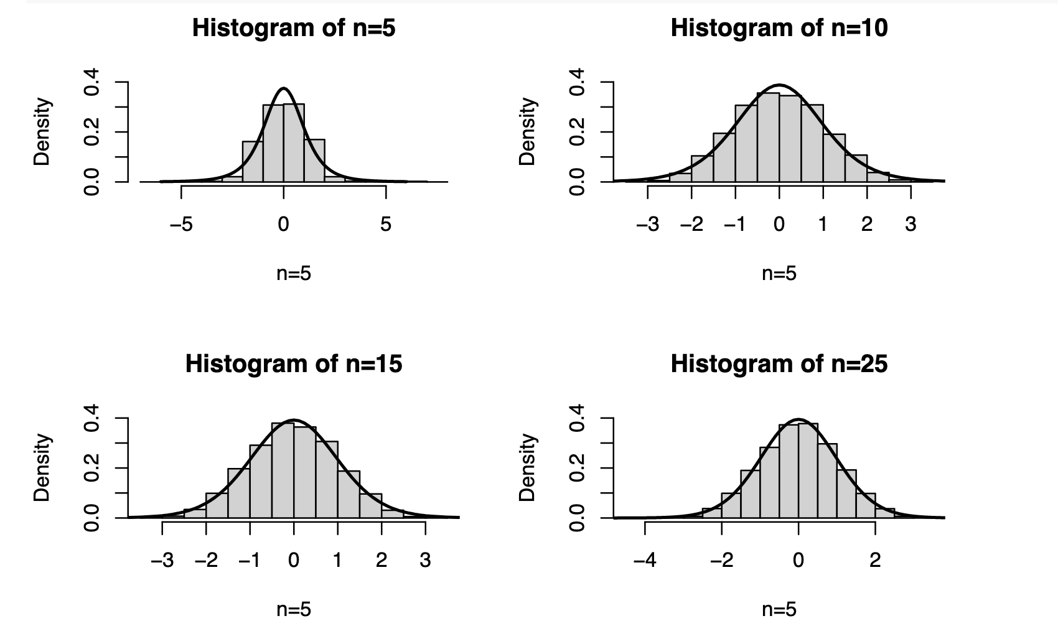

**Comparing quantiles of $T=\frac{z}{\sqrt{U/n-1}}$ and $t_{n-1}$ distributions**

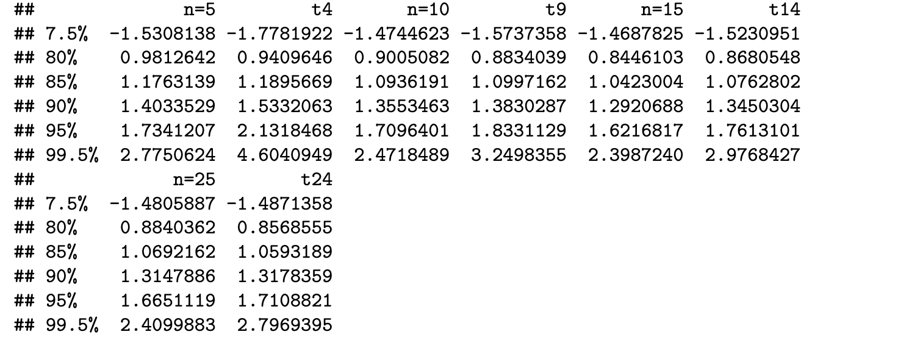

t4, t9, t14, and t24 stand for true quantiles of the $t_{n-1}$ distributions, respectively.

**Conclusion**

From the table above, we observe that $T$ does not follow $t_{n-1}$ distribution because there is a significant difference between estimated value and true value at p=0.995. Since there is a significant difference after 10000 simulations, the independence of $Z$ and $U$ is both necessary and sufficient for $T$ to have a $t_{n-1}$ distribution. When $n$ increases, the difference of quantiles is not significant. There is a situation in which it would be reasonable to approximate the distribution of $T$ with the $t_{n-1}$ distribution, such as $n$ is greater than 25.

**APPENDIX**

The following is R-code used to conduct Monte Carlo simulation. What’s written after # is the explanation of the codes.

#Produce the same random values

set.seed(2022)

#Set the function

Tvalue = function(X,n){

Z <- X[[1]]

U <- (n-1)*var(X)

t <- Z/sqrt(U/(n-1))

return(t)

}

#Do the simulation

R=10000

T5 <- rep(0,R)

T10 <- rep(0,R)

T15 <- rep(0,R)

T25 <- rep(0,R)

for (i in 1:R){

X5 <- rnorm(5,0,1)

X10 <- rnorm(10,0,1)

X15 <- rnorm(15,0,1)

X25 <- rnorm(25,0,1)

T5[i] <- Tvalue(X5,5)

T10[i] <- Tvalue(X10,10)

T15[i] <- Tvalue(X15,15)

T25[i] <- Tvalue(X25,25)

}

#Plot the histogram

x=seq(-5,5,0.01)

par(mfrow=c(2,2))

hist(T5,freq=FALSE,main="Histogram of n=5",xlab="n=5",ylim = c(0, 0.4))

curve(dt(x, 4), -6, 6, add=T,lwd = 2, ylim = c(0, 0.4))

hist(T10,freq=FALSE,main="Histogram of n=10",xlab="n=5",ylim = c(0, 0.4))

curve(dt(x, 9), -6, 6, add=T,lwd = 2, ylim = c(0, 0.4))

hist(T15,freq=FALSE,main="Histogram of n=15",xlab="n=5",ylim = c(0, 0.4))

curve(dt(x, 14), -6, 6, add=T,lwd = 2, ylim = c(0, 0.4))

hist(T25,freq=FALSE,main="Histogram of n=25",xlab="n=5",ylim = c(0, 0.4))

curve(dt(x, 24), -6, 6, add=T,lwd = 2, ylim = c(0, 0.4))

#Set the function

qvalue=function(x){

q <- c(quantile(x,0.075),quantile(x,0.8),quantile(x,0.85),quantile(x,0.9),quantile(x,0.95),quantile(x,0.995))

return(q)

}

q_t = function(n){

q <- c(qt(0.075,n-1),qt(0.8,n-1),qt(0.85,n-1),qt(0.9,n-1),qt(0.95,n-1),qt(0.995,n-1))

return(q)

}

#Create the quantile table

q5 <- qvalue(T5)

q10 <- qvalue(T10)

q15 <- qvalue(T15)

q25 <- qvalue(T25)

q_t5 <- q_t(5)

q_t10 <- q_t(10)

q_t15 <- q_t(15)

q_t25 <- q_t(25)

q <-c('0.075','0.8','0.85','0.9','0.95','0.995')

q_table<-data.frame(q5,q_t5,q10,q_t10,q15,q_t15,q25,q_t25)

colnames(q_table)<-list('n=5','t4','n=10','t9','n=15','t14','n=25','t24')

print(q_table)